Feral hemp (aka ditch weed; Cannabis sativa) site characterization in Wisconsin and surrounding states:
A request for help from researchers at the University of Wisconsin
We are researchers at the University of Wisconsin studying feral hemp (aka ditch weed; Cannabis sativa) throughout the North Central Midwest, and we’re reaching out to you for help locating populations. Do you know of feral hemp growing anywhere in Wisconsin or surrounding states? If so, would you be willing to share some basic geographic and demographic information with us?
A brief summary of our research
Midwest farmers struggle with decreased revenue resulting from globalization, technological advancements, and extreme weather events, and diversifying agriculture can increase economic potential and help build more sustainable agricultural systems in our region. Hemp (Cannabis sativa) is an alternative crop that can be used to diversify regional agriculture; however, a lack of institutional research over the past 70 years has left hemp farmers with relatively little foundational agronomic knowledge and poorly adapted cultivars. We are working to identify and characterize feral hemp populations in the Midwest in an effort to utilize this unique resource to help the burgeoning hemp industry. Our project objectives are to: 1) Characterize phenology and preserve seed from feral hemp populations, 2) Identify site conditions in feral hemp populations and relate those conditions to Eurasian Hemp Borer (an insect pest) resistance and higher yielding hemp cultivars, and 3) Identify sources of Eurasian Hemp Borer resistance from feral hemp that can be used to create higher yielding hemp cultivars for midwestern farmers.
How you can help
We’re asking for the public’s help in locating populations of feral hemp to include in our study. You can share your information about feral hemp with us in one of two ways, either via iNaturalist or by filling out the information below and sending it to us via email or the US postal service. Instructions for each option can be found below. Once suitable sites have been located through this inquiry, the research team will work to collect site-specific data on plant population and habitat attributes within the context of our research goals. Not all sites will be visited, and those located on private property will not be visited (or their location information shared with others) without consent from property owners.
- Instructions for using iNaturalist, a free crowdsourcing nature application available through an application on your mobile device or via a web browser:
To download and install the iNaturalist application on your mobile device, search for iNaturalist on Google Play or the App Store (depending on your device). Once the application is installed, create a new account or sign into an existing account if you already have one. Alternatively, to use iNaturalist via a web browser, navigate to https://www.inaturalist.org/. Once there, create a new account or sign into an existing account if you already have one.
Whether you’re using the iNaturalist application on your mobile device or interacting with iNaturalist via a web browser, to share your information about feral hemp with us you’ll need to add a new “observation” to the iNaturalist database by tapping on  (Apple device) or  (Android device) or by clicking  (web browser). Detailed instructions for adding observations using the application or a web browser can be found here: https://www.inaturalist.org/pages/getting+started.
When adding an observation, you’ll be asked to upload one or more photos of the hemp plants at your site. Please do your best to submit clear, well-framed photos to allow for unambiguous species identification/verification. In most cases, the iNaturalist system will use the metadata attached to your image(s) to automatically fill in site location information and the date of the observation. If this does not happen, please do so manually using the corresponding dialogue boxes.
In the “What did you see” (mobile device application) or “Species name” (web browser) dialogue box, please type in “Hemp” or “Cannabis sativa”.

- Instructions for sending your information directly to us via email or the US postal service:
Information about feral hemp can be sent directly to Brian Barringer via email at bbarring@uwsp.edu. If you prefer to send your information via the US Postal Service, the mailing address is: Brian Barringer, Department of Biology UWSP, 2101 Fourth Ave, Stevens Point, WI 54481.
We request that you send us the following information. You can enter your information directly into this document or use a separate document, whichever is more convenient for you.
Your name:
Your contact information (phone or email address is fine):
Site location (GPS coordinates preferred, though a street address or location along a road is fine):
Private or public property:
Approximate number of plants:
One or more photo(s) of site and/or plants (at least one photo of site with multiple plants in view preferred):
Example:
Name: Shelby Ellison
Contact information: slrepinski@wisc.edu
Site location: 43.07456, -89.64588
Private or Public Property: Public
Approximate number of plants: ~100 plants
One or more photo(s) of site/plants:
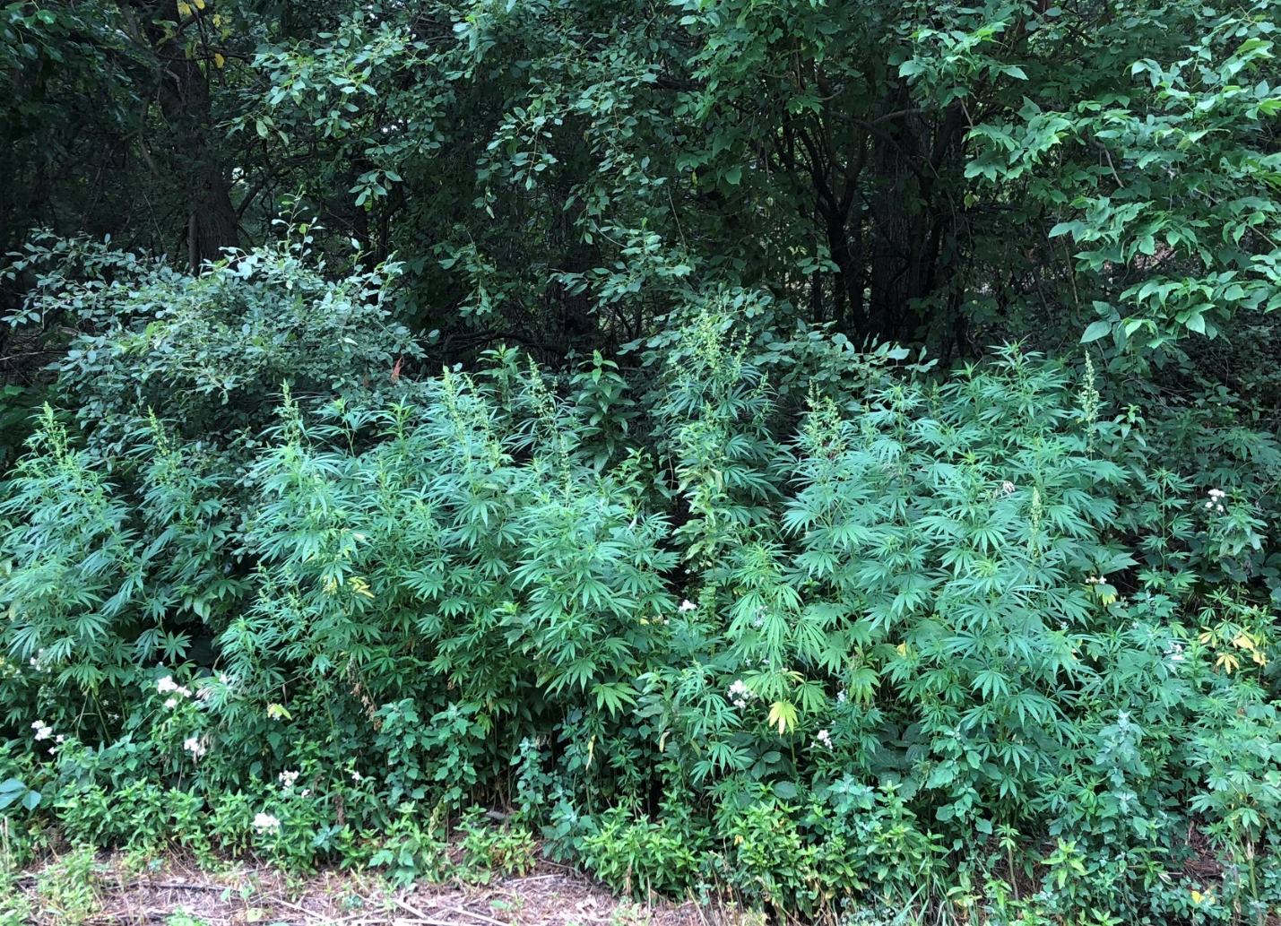
If you have questions or need assistance, please don’t hesitate to reach out to us via email (bbarring@uwsp.edu) or phone (715-346-2452).
Thank you for your help!
Brian Barringer (Department of Biology, College of Letters and Science, UW Stevens Point)
Autumn Brown (Department of Horticulture, College of Agricultural and Life Sciences, UW Madison)
Shelby Ellison (Department of Horticulture, College of Agricultural and Life Sciences, UW Madison)
Russell L. Groves (Department of Entomology, College of Agricultural and Life Sciences, UW Madison)
Sophia Risch (Department of Biology and College of Natural Resources, UW Stevens Point)
Bryant Scharenbroch (College of Natural Resources, UW Stevens Point)

