Food as Medicine
An overview of spices and foods that can be beneficial to health
With David Kiefer, MD
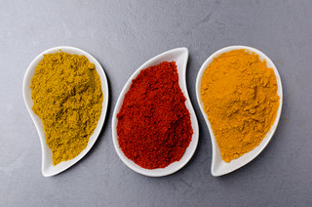

Learn about garlic, turmeric, cinnamon, prickly pear cactus, rosemary, sage, and many others!

- Learn how these beneficial foods and spices should be consumed
- Which health conditions benefit from these foods
- Understand about the fascinating multi-cultural aspects

When: Tuesday, October 15
12:00-12:30 P.M.

Where: Babcock Hall
1605 Linden Drive
Room 205

For more Information, please contact Krista DeJoode at dejoode@wisc.edu. This lunch and learn is hosted by the CALS Wellness Committee and a few light snacks will be available at the event.

