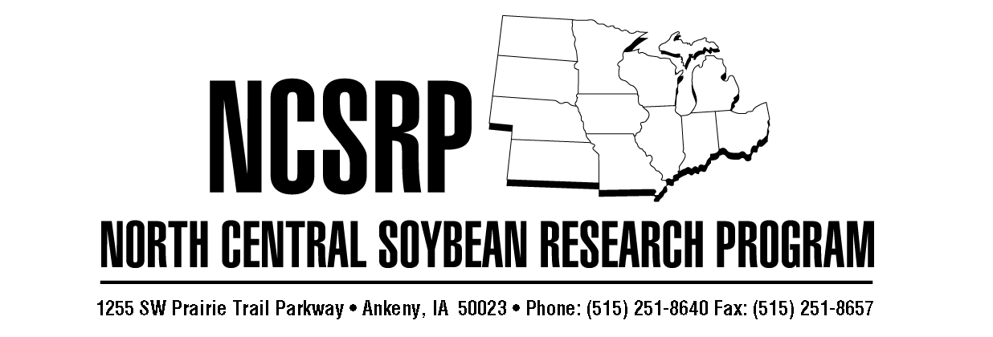
North Central Soybean Research Program (NCSRP) Request for Research Proposals for 2016/2017 Funding
Please note time-sensitive material. Distribute to appropriate Faculty and Staff as soon as possible. Important Dates:
- NCSRP RFP sent to Universities: March 16, 2016.
- Proposals due: By end of business on May 20, 2016.
- NCSRP Board Proposal Review and Funding Decisions: August 2016.
- FY 2017 funding cycle: October 1, 2016 to September 30, 2017.

The North Central Soybean Research Program (NCSRP) combines soybean check-off funds from its 12 member states in order to sponsor basic and applied research to increase soybean profitability and enhance yield, while maintaining or improving soybean composition, through genetic improvement and biotic and abiotic stress mitigation for soybean maturity groups 0 – IV.
The NCSRP is seeking soybean research project renewal requests and new proposals for funding to begin on October 1, 2016. The NCSRP Board will fund research projects that address their goals to increase soybean grower productivity and profitability while improving environmental stewardship. The NCSRP will fund both applied and basic research, and the communication of research results, to provide short- and long-term practical benefit to Midwestern soybean producers. Projects must logically fit into one of these key research areas:
- Soybean yield enhancement through classical and molecular breeding to increase genetic yield potential and yield stability via gene discovery and germplasm development, while maintaining or improving soybean composition, for the North Central Region.
- Basic and applied research directed at soybean disease, nematode, insect pest and abiotic stress biology, management and yield loss mitigation, including new and emerging threats, of consistent or potentially significant economic impact across the North Central Region.
- Management of weed resistance to herbicides for species of common occurrence and threat across the North Central Region.
- Basic and applied research that addresses soybean response to water, nutrients, climate, soil and environmental conditions specific to the North Central Region.
- Soybean production practices & crop management for increased yields and profitability in an environmentally sustainable manner.

Research proposals are expected to be concise (not more than 7 pages) and contain the following (see attached proposal template):
- Cover Sheet (provided): proposal overview and budget
- Contact Information: Name, address, phone number, email address for PI as well as co-PI’s and affiliation of principal investigator and collaborators as well as Sponsors Programs & Contracts office for PI’s university.
- Project Title
- Brief Project Justification and Rationale: Identified research need, brief review of similar academic and industry research and how proposed research is necessary, novel and how it will benefit soybean growers.
- Brief Description of Proposed Research: Work/experiments to be done, purpose, expected outcome, contribution to project goal and clear statement of communication and outreach strategies.
- Other Funding: Proposed research may complement and extend, but must not duplicate already funded research. Where applicable, a concise listing of related research and funding sources for the PI and collaborators, and a brief description of how this checkoff funded research will be used to attract or complement additional funding support (public and private: e.g. USB, QSSB, USDA, company) to extend knowledge or expand research breadth and depth, especially in cases where basic research funding is requested.
- Clear and concise set of Project Metrics and Performance Measures, Milestones and Deliverables, including:
  - Key Performance Indicators (KPIs) or performance metrics and how those will be measured
  - If appropriate, an analysis of program/project economic impact and significance to soybean farmers
  - Timelines and milestones for extending the state-of-the-art of basic and applied research
- Clear description of a Cost-Efficient Budget, sub-budgeted to projects within programs.

It is critically important for researchers to develop collaborative regional projects, to identify how the deliverables will positively and tangibly impact Midwest soybean producers in the short- or long-term, and how deliverables will be communicated to growers and to the NCSRP. Researchers should emphasize first year deliverables when requesting multi-year projects, as continued funding will be determined by the demonstration and communication of real and meaningful first-year results.
Researchers are strongly encouraged to demonstrate interdisciplinary and interuniversity approaches and collaborations. If possible, researchers should consider submitting larger program proposals with clearly described and sub-budgeted projects within the program proposal. While individual projects will be considered, program proposals often demonstrate coordinated, non-redundant and potentially higher impact research and communication efforts to advance soybean farmer and industry priorities.
Researchers interested in submitting a proposal should provide an electronic copy in Microsoft Word format to Sue Heath at sheath@iasoybeans.com and Dr. Ed Anderson eanderson@iasoybeans.com by May 20, 2016. Five (5) original hard copies of the complete proposal should be mailed to Sue Heath, NCSRP, 1255 SW Prairie Trail Parkway, Ankeny, IA 50023. Questions can be addressed to Dr. Ed Anderson, telephone (515) 334-1059 or email at eanderson@iasoybeans.com.
Funds granted through this program are checkoff funds contributed to Qualified State Soybean Boards pursuant to the Soybean Promotion, Research and Consumer Information Act, 7 U.S.C. 6304 (1) (4). Work performed under this Agreement will be performed in accordance with the Soybean Promotion, Research and Consumer Information Act and the Soybean Promotion and Research Order, 7 CFR Part 1220.

