United States Department of the Interior
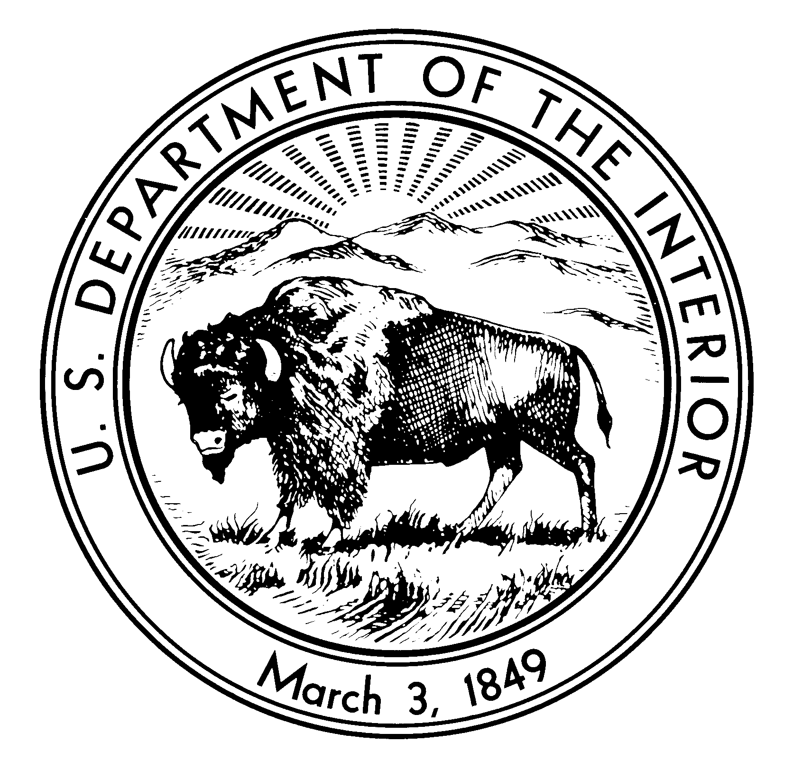

NATIONAL PARK SERVICE
Northeast Region Archeology and Ethnography Program
4th Floor Boott Cotton Mills Museum
Lowell, MA 01852

Letter of Research Interest (LOI)

Title: Roger Williams National Historic Site Ethnographic Study

The Northeast Region Archeology and Ethnography Program is interested in conducting an Ethnographic Overview and Assessment (EOA) for Roger Williams National Memorial (ROWI). Partners of the national Cooperative Ecosystem Studies Unit Network (CESU: http://www.cesu.psu.edu) are invited to respond to this request for Letters of Research Interest.

The project will provide baseline ethno historical and ethnographic documentation of the historic and contemporary relationships and associations Native Americans have with the site of Roger Williams National Memorial (ROWI). The 4.5 acre site is nationally significant due in large part to Williams’ significant contributions to the “principles of freedom” in the United States that were incorporated into the founding documents of our nation a century later.

At least some of these principles of freedom were practiced and reflected in his treatment and interaction with Native American peoples in the 17th century. Williams mediated colonial interests among the Native people, particularly the Narragansett and Wampanoag. Williams was one of the first to write objectively about native lifeways and practices, accurately describing the political organization of the Narragansett. Further, Williams provided a moving portrait of Narragansett leaders in his correspondences and mediated diplomatic crises between colonists and the native people. As a linguist, Williams’ study of the Narragansett and Algonquin languages, culminated in the first published study of an Amerindian language in English.

The project will culminate in the development of an Ethnographic Overview and Assessment (EOA) for ROWI. This document will enhance the park’s and the public’s understanding of Williams’ associations with Native Americans and Williams’ notions of civil rights and equality among human beings which was demonstrated in his positions regarding Native American land rights and “soul liberty.

The study will identify the roles, relationships, associations, and significance specific Native American Indian tribes and/or nations attach to ROWI. The project will provide a meaningful exchange of knowledge and ideas that will enhance scholarly research and the park’s and public’s understanding of ROWI, will identify which Native American tribes and/or nations attach cultural meaning and significance to ROWI, will identify areas of shared interest and/or scholarship, and will identify other areas in which future consultation and cooperation is desired, warranted, or requested. An important goal of this project will be to represent holistically and with objectivity the legacy of Roger Williams from a tribal perspective.

The Northeast Region (NER) Ethnography Program acting on behalf of ROWI is seeking a partner to aid in identifying and understanding historic and contemporary Native American associations with ROWI. The partner will be tasked with completing an ethnographic study that will document the historic relationship and contemporary values and beliefs Native peoples have regarding ROWI.

The Ethnographic Overview and Assessment will review existing information on park resources traditionally valued by stakeholders. It will attempt to identify park resources such as landscapes and objects, that are important to a people's sense of purpose and provide an overview of major themes regarding culture and lifestyle and their implications for ROWI resource managers. Information for the completion of the EOA will come mostly from archives and publications and will be supplemented by interviews with tribal and community members and other constituents. This will involve trips to specific sites to supply any missing ethnographic data. The study will also identify areas for future research and collaboration. The EOA study is one of many undertaken by the National Park Service to inventory the wide range of resources (natural, historic, archeological, ethnographic) that are found on park lands. Results of studies like these are fully considered in resource management plans, park interpretive or educational programs, and in the day-to-day operations of parks.

Nature of Work Required

NER Ethnography Program envisions the project will:

- Provide a meaningful exchange of knowledge and ideas that will enhance scholarly research and the park’s and public’s understanding of Roger Williams,

- will identify which Native American tribes and/or nations attach cultural meaning and/or significance to ROWI,

- will identify areas of shared interest or scholarship, and

- will identify other areas in which future consultation and cooperation is desired, warranted, or requested.

NER Ethnography Program is looking for a partner that can conduct an ethnographic study of ROWI. Responses to this LOI should briefly identify the specific capabilities within the CESU partner institution that will allow them to address the needs of the project, including identification of the relevant departments, faculty, students, and resources that will be involved in the project. Response to this LOI should also briefly outline their approach to the project. A proposed budget is not required at this time.

NER Ethnography Program’s substantial involvement with the project will include: providing the cooperator previously collected ethnohistorical and ethnographic studies; coordinating and consulting the findings with the appropriate park units, the State Historic Preservation Offices (SHPO), and Tribal Historic Preservation Offices (THPO); assisting the cooperator in locating and determining park and jurisdictional boundaries; and aiding the cooperator in producing a report on the project that meets the Secretary of the Interior’s standards.

Project Timeframe

Deadline for responding to this letter of interest is March 25, 2016.

Requirements

The research will be directed and overseen by a Principal Investigator (PI). The PI should be an applied cultural anthropologist with a Ph.D., or with demonstrable and comparable research. The researcher must demonstrate significant involvement in the research, writing, and the timely completion of ethnographic research.

Products

The products from this project will include a report documenting the ethnographic study.

Funds Available

Project funds available are $90,000 that includes the CESU overhead rate of 17.5 percent. The project will be funded by the National Park Service. Only non-federal partners within the national CESU network are eligible to apply.

Letters of Interest

Letters of Interest (LOI) should be sent to the addresses located in the “contact” section. LOI’s will be reviewed by a panel. The panel will select the top candidate(s) who will be asked to provide and submit a full proposal detailing the work to be done, providing and describing the methodology and research design, and outlining a schedule of deliverables.

The LOI should describe your research interest(s) in the projects, past projects that are similar in topic and/or form, and any relevant experience in completing ethnographic projects. Please include your name, affiliated organization(s), and contact information. Please try and limit LOI’s to 2 pages.

Contact

Responses of interest should be directed before the closing date to Erik Kreusch (Erik_S_Kreusch@nps.gov). Additional questions can be answered by contacting Erik Kreusch , Cultural Anthropologist, Northeast Region Ethnography Program, National Park Service (978-970-5144).

