
A Night on the Farm
Helping fight local hunger
Thursday, Sept. 24th 3:30 p.m. – 6:30 p.m.
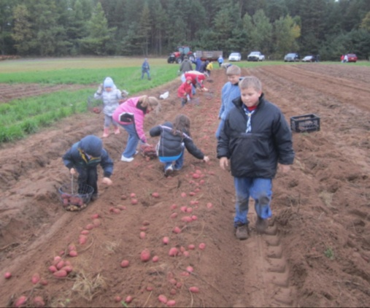
The UW-Rhinelander Agricultural Research Station and WI Potato & Vegetable Growers Association (WPVGA) in cooperation with our Area Food Pantries, are hosting an event to provide for local food needs. We are looking for family and friends to help us pick potatoes for our local food pantries. In addition to the picking, we are accepting additional non-perishable food items for donation. As a thank you, we welcome participants to pick potatoes to take home!
What’s in it for you?
-Help provide food for our local pantries.
-Have a fun night of learning and being outside with family & friends.
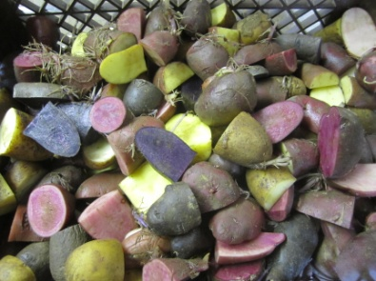
-Come see The Wisconsin Spudmobile – the WI potato industry’s most comprehensive educational and informational on wheels resource center.
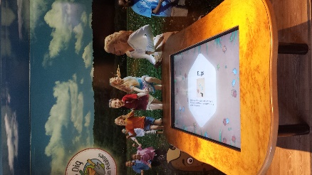
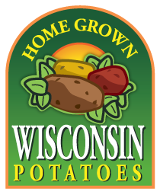
-Take a few pounds of potatoes home!
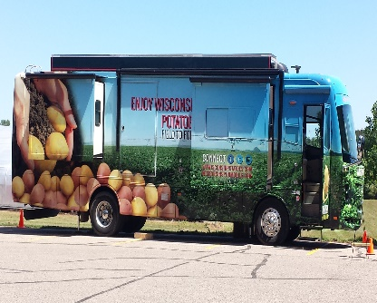
Light refreshments and food will be served.
This is an informal event for individuals or the whole family. Please bring a container to pick and take your potatoes home!
Directions: Field is located 6.5 miles east of the Ice Arena on Cty. Hwy. C, on the right, watch for signs. Google map: http://rhinelander.ars.wisc.edu/map-directions/
News Announcement: The UW-Rhinelander Agricultural Research Station and WI Potato & Vegetable Growers Association (WPVGA) in cooperation with our Area Food Pantries, are hosting an event to provide for local food needs. A Night on the Farm – Helping fight local hunger will be held on Thursday, September 24th from 3:30-6:30 p.m. and include opportunities to pick potatoes for area food pantries. You will have the opportunity to learn about the research conducted by the UW Rhinelander Research Station as well as experience The Wisconsin Spudmobile – the WI potato industry’s most comprehensive educational and informational on wheels resource center. In addition to the picking for the Food Pantries, the station will be accepting additional non-perishable food item donations. Potatoes picked and donated items will be distributed in Rhinelander and other North Central Wisconsin communities. This is an informal event for individuals or the whole family. Light refreshments and food will be served. Please bring a container to pick and take your potatoes home!
Directions: Field is located 6.5 miles east of the Ice Arena on Cty. Hwy. C, on the right, watch for signs. Google map: http://rhinelander.ars.wisc.edu/map-directions/
