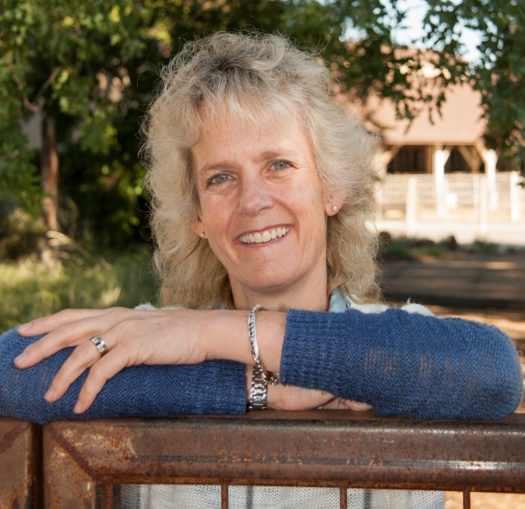
2015 Arthur B. Chapman Lectures in Animal Breeding and Genetics
Dr. Alison L. Van Eenennaam
University of California, Davis

The 2015 Arthur B. Chapman Lectures in Animal Breeding and Genetics at the University of Wisconsin-Madison will be presented on May 5 and May 6, 2015 by Dr. Alison L. Van Eenennaam, Cooperative Extension Specialist of Animal Genomics and Biotechnology, Department of Animal Science, University of California, Davis.

Dr. Van Eenennaam received a B.Sc. (Honors) degree in Agricultural Science from the University of Melbourne, Victoria, Australia and the M.S. (Animal Science) and Ph.D. (Genetics) degrees from the University of California, Davis. Prior to her appointment to the faculty in Animal Science at Davis, she worked as a Development Scientist for Coopers Animal Health in Australia, as a Regional Dairy and Livestock Farm Advisor in California, and as a Research Scientist and Project Leader for Calgene in California.

The focus of her research and outreach programs are on the use of animal genomics and biotechnology in livestock production systems; specifically integrating DNA information into beef cattle production systems to provide commercial cow-calf producers with the background information and research-derived data they need to make informed decisions about the use of DNA-technologies in their operations.

Dr. Van Eenennaam has received several awards for her research and outreach programs including the National Award for Excellence in Extension from the American Association of Public and Land-Grant Universities, the Extension Award from the American Society of Animal Science, and the Academic Federation Award for Excellence in Research from the University of California, Davis. Alison is widely recognized for her skills as a communicator on the benefits to society of the use of biotechnologies for the efficient production of animal products. In 2014, she received the Borlaug Communication Award from the Council of Agricultural Science and Technology.

May 5
12:05 p.m., Room 209, Animal Science Building
“Lysenkoism: learning from the past to facilitate the future of animal breeding”

May 6
8:50 a.m., Room 212, Animal Science Building
"Biotechnology and animal breeding: a match made in heaven"

by

Dr. Alison L. Van Eenennaam
Cooperative Extension Specialist of Animal Genomics and Biotechnology Department of Animal Science
University of California, Davis

The A.B. Chapman Lectures in Animal Breeding and Genetics have been presented annually since 1994 by leading world scholars in the various fields related to genetic improvement of livestock. Previous A.B. Chapman Lecturers have been:

Dr. Brian W. Kennedy (Canada, 1994); Dr. Jean-Louis Foulley (France, 1995); Prof. William G. Hill (United Kingdom, 1996); Dr. Brian P. Kinghorn (Australia, 1997); Dr. R. Leyden Baker (Kenya, 1998); Dr. Louis Ollivier (France, 1999); Prof. Morris Soller (Israel, 2000); Dr. Laurie Piper (Australia, 2001); Prof. Max. F. Rothschild (Iowa State University, 2002); Prof. James F. Crow (University of Wisconsin-Madison, 2003); Prof. L. Dale Van Vleck (USDA and University of Nebraska at Lincoln, 2004); Prof. Jack C. M. Dekkers (Iowa State University, 2005); Prof. E. John Pollak (Cornell University, 2006); Prof. Leo Dempfle (Germany, 2007); Prof. Agustin Blasco (Spain, 2008); Prof. Miguel A. Toro (Spain, 2009); Prof. Daniel Sorensen (Denmark, 2010); Prof. Trudy Mackay (North Carolina State University, 2011); Prof. Dorian Garrick (Iowa State University, 2012); Prof. Henner Simianer (Germany, 2013); and Prof. Jeremy Taylor (University of Missouri, 2014).

The 2015 A. B. Chapman Lectures in Animal Breeding and Genetics are sponsored by Genus PIC (Swine Genetics) and Genus ABS (Bovine Genetics), De Forest, Wisconsin and the A. B. Chapman Fund, University of Wisconsin Foundation. Tax deductible contributions to the A. B. Chapman Fund can be made at: http://www.supportuw.org/.

