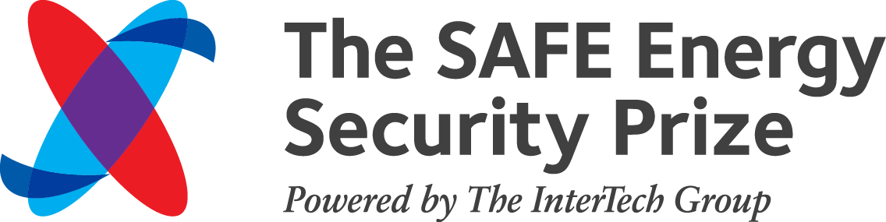
Introduction

Securing America’s Future Energy (SAFE) is pleased to announce that it is now accepting applications for the second installment of the SAFE Energy Security Prize, supporting companies, institutions and individuals whose ingenuity, leadership, and perseverance are poised to advance American energy security by helping to end U.S. oil dependence.
The SAFE Energy Security Prize, Powered by the InterTech Group will recognize up to three technologies that are not currently in the marketplace, but are expected to be available for sale within five years. The technologies must have the potential to meaningfully reduce long-term U.S. oil consumption. The first place winner will receive $125,000 in prize money. The first runner-up will receive $35,000 and the second runner-up will receive $15,000.
2015 Prize applications will be evaluated on the following criteria: oil displacement potential, competitive advantage over existing/incumbent technologies, cost trajectories and ease of getting to scale, industry interdependence, technology and market validation, and value to the end user.
All submissions are due by April 10th, 2015. The semi-finalists will be announced May 11, 2015 and the winners will be announced at an event on June 23rd.
To learn about the Prize and to see if your technology qualifies, please find more information below.

Instructions

To apply, please visit www.secureenergy.org/prize to download an application form. Please complete the application as specified and submit it to https://www.valideval.com/energy_prize_2015/signup/team_signup.php by April 10, 2015.

The Energy Security Prize is designed to recognize and promote innovation in alternative transportation and new industrial and petrochemical processes with the ultimate goal of significantly reducing oil consumption in the United States. The Energy Security Prize will reward new innovators who will substantially reduce oil consumption in the coming years.

Eligibility and Evaluation

Technologies that apply should:

- Not yet be in the marketplace;
- Be available for sale within the next five years;
- Have the potential to displace significant volumes of petroleum consumption in a key end-use sector (primarily transportation, but also industrial and petrochemical sectors);
- Possess strong future market potential.
Applications will be evaluated based on the following criteria. Please see the application form (www.secureenergy.org/prize) for further details.

Eligibility is not restricted by type of institution.

Solution / Product
- The technologies’ competitive advantage over the incumbent technology.
- Cost trajectories and ease of getting to scale.

Oil Displacement Potential
- How much oil can the technology displace per unit?
- What is the cumulative potential effect by 2025?

Technology and Market Validation
- Customer Engagement.
- Partnership.
- Market Sizing Analysis.

Industry Interdependence
- Exposure to infrastructure and regulatory hurdles.
- Non-intellectual property barriers to entry.

Risk Narrative
- Identifying and overcoming risk.
Review & Selection Process
The Review and Selection Process will encompass two rounds and winners will be chosen by a weighted vote of an expert Selection Panel and the public via online voting. The Selection Panel is comprised of representatives from industry, venture capital, academia, the national laboratories, other non-profit research groups, and leaders in the energy field.

Round One will consist of a review of each application by the Selection Panel. Multiple members will be assigned to each application, and the applicant’s final score will be an average of all reviewers. The most competitive submissions will provide a compelling and concise explanation of the oil displacement and energy security implications of the applicant’s technology and clearly illustrate how the applicant meets the application criteria.

A select number of Round One applicants will advance to Round Two as semifinalists. The semifinalists will be invited to give a 10-minute presentation of their technology before the Selection Panel. Presentations to the panel will take place the week of June 1, 2015 and will be video recorded. The quality of the presentation will be factored into the selection process. The panel members will also receive an opportunity to ask questions immediately following the presentation. At the conclusion of the semifinal presentations, Selection Panel members will provide their s.

The video-recorded presentations of the semifinalists will be made available online for public voting before the announcement of the winners. Semifinalists will also be invited to give their 10-minute presentations at the awards event on June 23, 2015, and the person who presented to the Selection Panel in Round Two must be able to present at this opportunity. Winners will be selected by a combination of the scores received from the Selection Panel from Round Two (80 percent) and online public votes (20 percent). Winners will be announced at the June 23rd public event.

Additional Information

Status
SAFE will make every effort to inform applicants regarding the status of their entries in a timely manner. Applicants will be notified as to whether they have been selected as semifinalists to advance to Round Two the week of May 11, 2015. All semifinalists should be prepared to attend the final event on June 23, 2015 at which the grand prize winners will be announced.

Requirements & Restrictions
Applicants are responsible for their own travel and lodging arrangements and expenses, and any additional expenses which may be incurred by them through participation in this competition. If applicants are unable to participate as stipulated in any rounds for which they are selected, they will forfeit their entry.

Entities and individuals which are bankrupt, in the process of closing, or which have or are planning to suspend business operations are not eligible. SAFE reserves the right to disqualify applicants at our sole discretion including for misrepresentation of facts or other information. There is no requirement that any prize(s) be awarded if the Selection Panel determines that there are no applicants worthy of receiving a prize.

About Securing America’s Future Energy (SAFE)
Securing America’s Future Energy (SAFE) is a non-partisan alliance of prominent CEOs and retired four-star military leaders who believe that America’s dependence on oil is a severe threat to the national security and economic prosperity of the United States. SAFE’s Energy Security Leadership Council (ESLC) is co-chaired by Frederick W. Smith, Chairman, President, and CEO of FedEx Corporation, and General P.X. Kelley (USMC, Ret.), the 28th Commandant of the Marine Corps and the first Commander of the Rapid Deployment Joint Task Force (the precursor to U.S. CENTCOM). SAFE’s ideas have gained support at the highest levels of government and the private sector. SAFE’s sister organization, the Electrification Coalition (EC), is the primary partner in two separate electric vehicle deployment community initiatives in Northern Colorado and Orlando, respectively.

